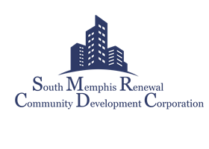

Equal Opportunity

South Memphis Renewal Community Development Corporation is an equal opportunity employer. SMRCDC employs qualified individuals without regard to their race, color, religion, creed, sex, national origin, citizenship, age, disability, genetic predisposition or carrier status, marital status, sexual orientation, uniformed service, protected activity (e.g., opposition to prohibited discrimination or participation in proceedings, covered by the anti-discrimination statuses) or any other characteristic protected by law. Toward this end, all employment-related activities are conducted on a non-discriminatory basis in full compliance with federal, state and local laws prohibiting discrimination in employment. Violations of this policy are strictly prohibited.

___________________________
Participants Name (Print)

___________________________
Participants Signature

_________________________
Date

